**MySql**

**Python Assignment**

**16 Feb 2023**

**Q1. What is a database? Differentiate between SQL and NoSQL databases.**

**Sol.** A **database** is an organized collection of data, so that it can be easily accessed and managed. You can organize data into tables, rows, columns, and index it to make it easier to find relevant information. **Database handlers** create a database in such a way that only one set of software program provides access of data to all the users. The **main purpose** of the database is to operate a large amount of information by storing, retrieving, and managing data. There are many **databases available** like MySQL, Sybase, Oracle, MongoDB, Informix, PostgreSQL, SQL Server, etc.

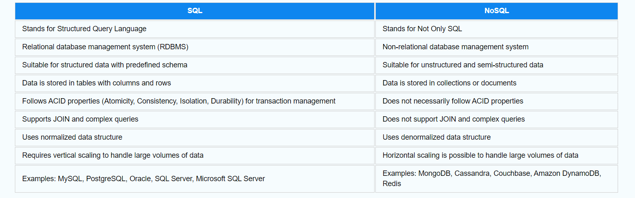

**Q2. What is DDL? Explain why CREATE, DROP, ALTER, and TRUNCATE are used with an example.**

**Sol.** Data Definition Language(DDL) is a subset of SQL and a part of DBMS(Database Management System). DDL consist of Commands to commands like CREATE, ALTER, TRUNCATE and DROP. These commands are used to create or modify the tables in SQL.

**DDLCommands:**  
In this section, We will cover the following DDL commands as follows.

1. Create
2. Alter
3. truncate
4. drop
5. Rename

**CREATE :**  
This command is used to create a new table in SQL. The user has to give information like table name, column names, and their datatypes.

Example.

CREATE TABLE Student_info

(

College_Id number(2),

College_name varchar(30),

Branch varchar(10)

);

**ALTER :**  
This command is used to add, delete or change columns in the existing table. The user needs to know the existing table name and can do add, delete or modify tasks easily.

Example.

ALTER TABLE Student_info

ADD CGPA number;

**TRUNCATE :**  
This command is used to remove all rows from the table, but the structure of the table still exists.

Example.

TRUNCATE TABLE Student_info;

**DROP :**  
This command is used to remove an existing table along with its structure from the Database.

Example.

DROP TABLE Student_info;

**Q3. What is DML? Explain INSERT, UPDATE, and DELETE with an example.**

**Sol.** The data manipulation language statements are used to retrieve, add, delete, and modify the data that is stored in the objects of database. The keywords or statements that are associated with the data manipulation language are: SELECT INSERT, UPDATE and DELETE.

INSERT Command

To add data to a table the INSERT command is used.

**Example,**

INSERT into EMPLOYEE values (10, ‘Management’, ‘E01’, ‘John Abraham’);

|  |  |  |  |
| --- | --- | --- | --- |
| **Dept_No** | **Dept_Name** | **Emp_No** | **Emp_Name** |
| 10 | Management | E01 | John Abraham |

### Update Command:

To update a table or row or column in the table we use the update command.

Example,

|  |  |  |  |
| --- | --- | --- | --- |
| **Dept_No** | **Dept_Name** | **Emp_No** | **Emp_Name** |
| 10 | Management | E01 | John Abraham |
| 20 | Management | E02 | Tim |
| 30 | Finance | E10 | Ali |
| 40 | Finance | E11 | Faddy |
| 50 | IT | E25 | Kate |

Update employee set EMP_NO = E04 where DEPT_NO = 30;

|  |  |  |  |
| --- | --- | --- | --- |
| **Dept_No** | **Dept_Name** | **Emp_No** | **Emp_Name** |
| 10 | Management | E01 | John Abraham |
| 20 | Management | E02 | Tim |
| 30 | Finance | E04 | Ali |
| 40 | Finance | E11 | Faddy |
| 50 | IT | E25 | Kate |

### Delete Command

To delete a table row or some data from a table in the database the delete command is used.

Example,

|  |  |  |  |
| --- | --- | --- | --- |
| **Dept_No** | **Dept_Name** | **Emp_No** | **Emp_Name** |
| 10 | Management | E01 | John Abraham |
| 20 | Management | E02 | Tim |
| 30 | Finance | E04 | Ali |
| 40 | Finance | E11 | Faddy |
| 50 | IT | E25 | Kate |

DELETE from employee where DEPT_NO = 40;

|  |  |  |  |
| --- | --- | --- | --- |
| **Dept_No** | **Dept_Name** | **Emp_No** | **Emp_Name** |
| 10 | Management | E01 | John Abraham |
| 20 | Management | E02 | Tim |
| 30 | Finance | E04 | Ali |
| 50 | IT | E25 | Kate |

**Q3. What is DQL? Explain SELECT with an example.**

**Sol.** The DQL statements can be used in order to query the data and information contained in schema objects. The goal of the DQL Commands is to return a schema relation on the basis of the query supplied to them.

Example,

|  |  |  |  |  |  |
| --- | --- | --- | --- | --- | --- |
| **Student_ID** | **First_Name** | **Address** | **Age** | **Percentage** | **Grade** |
| 201 | Akash | Delhi | 18 | 89 | A2 |
| 202 | Bhavesh | Kanpur | 19 | 93 | A1 |
| 203 | Yash | Delhi | 20 | 89 | A2 |
| 204 | Bhavna | Delhi | 19 | 78 | B1 |
| 205 | Yatin | Lucknow | 20 | 75 | B1 |
| 206 | Ishika | Ghaziabad | 19 | 91 | C1 |
| 207 | Vivek | Goa | 20 | 80 | B2 |

**SELECT** Student_Id, Age, Percentage, Grade **FROM** Employee;

|  |  |  |  |
| --- | --- | --- | --- |
| **Student_ID** | **Age** | **Percentage** | **Grade** |
| 201 | 18 | 89 | A2 |
| 202 | 19 | 93 | A1 |
| 203 | 20 | 89 | A2 |
| 204 | 19 | 78 | B1 |
| 205 | 20 | 75 | B1 |
| 206 | 19 | 91 | C1 |
| 207 | 20 | 80 | B2 |

**Q5. Explain Primary Key and Foreign Key.**

**Sol. Primary Key:-** A primary key generally focuses on the uniqueness of the table. It assures the value in the specific column is unique. The table allows only one primary key. The primary key doesn’t allow null values. It can identify the record uniquely in the database table. In the primary key, the value cannot be removed from the parent table. Its restriction can be completely defined on the temporary tables.

**Foregin Key:-** A foreign key is generally used to build a relationship between the two tables. Tables can allow more than one foreign key. The foreign key accepts multiple null values. A foreign key is a field in the table that is the primary key in another table. In this, the value can be deleted from the child table. Its restriction cannot be defined on the global or local temporary tables.

**Q6. Write a python code to connect MySQL to python. Explain the cursor() and execute() method.**

**Sol.**

**import** mysql.connector

  #Create the connection object

mycon= mysql.connector.connect(host = "localhost", user = "root",passwd = "google")

#printing the connection object

**print**(mycon)

A cursor is an object which helps to execute the query and fetch the records from the database. The cursor plays a very important role in executing the query.